To use division methods
Apply your knowledge of division by sharing.
6 ÷ 2 =

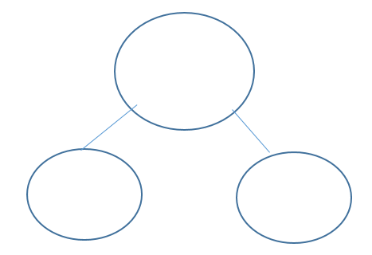
10 ÷ 2 =
8 ÷ 2 =

