Identify different line types on this painting. Discuss with an adult which are which; horizontal, vertical, perpendicular and parallel. One has been done for you.
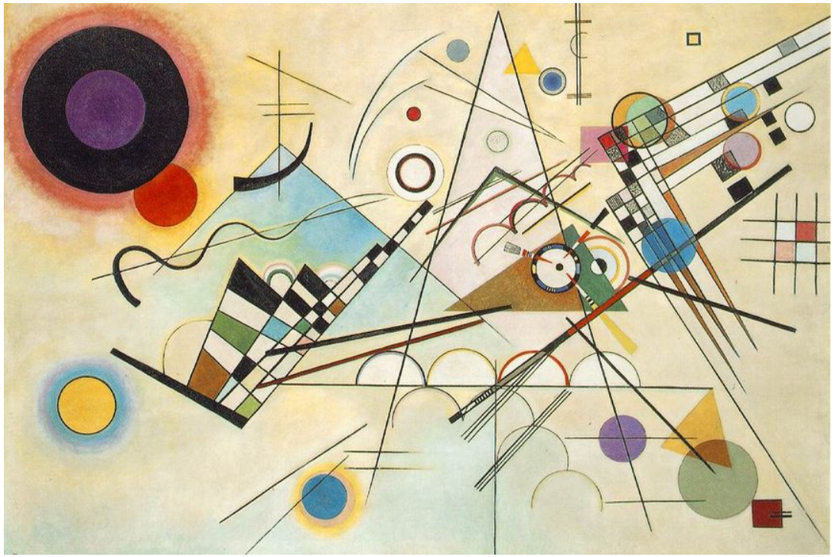
Vertical

