Geography : London Landmarks

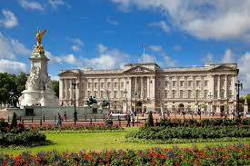 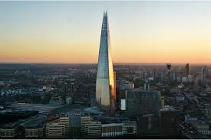

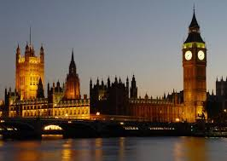

I see

|  |
| --- |
|  |
|  |
|  |
|  |
|  |

I know

|  |
| --- |
|  |
|  |
|  |
|  |
|  |

I wonder

|  |
| --- |
|  |
|  |
|  |
|  |