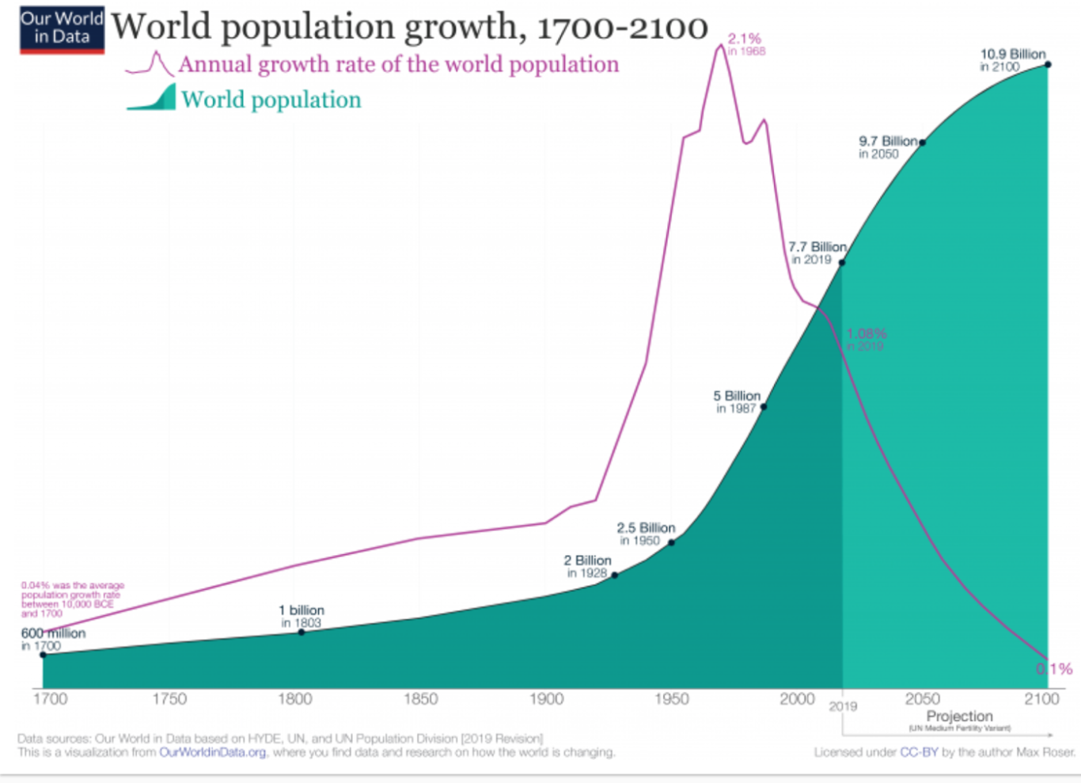
Geography Learning intention – To observe and understand world population over time
Look at the graph below. Analyse the information to help you identify which statements are true and false and give reasons for your answers.

True or false?
- Since the year 2000, the population has been growing at a faster and faster rate.
- In the 1800’s the population of the world was 1 billion.
- From 1950 to 1987 the population doubled.
- The world population steadily increased from the 1700’s to the 1950’s and then increased at a faster rate after that.
- There will definitely be 9.7billion people in the world in 2050.
- The annual growth rate in 1968 was the highest it has ever been.
- The annual growth rate in the 1800 was lower than in 1750.
- Between 1950’s and 2000’s the annual growth rate fluctuated.
- The growth rate in 2100 will definitely be 0.1%.
- The world growth rate is lower than the annual growth rate throughout the graph.

