Finding thirds $\frac{1}{3}$
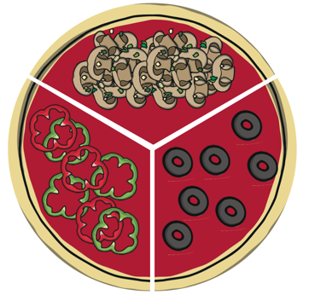
Reminder: The numerator (1) shows we need to count 1 group, the denominator (3) shows there are 3 groups or parts altogether.
Can you write the fraction in the box?
My pizza is mushroom My pizza is olive

My pizza is peppers

Circle a third Circle a third

Find:
$\frac{1}{3}$ of 15

$\frac{1}{3}$ of 21

$\frac{1}{3}$ of 30

Can you find a quicker way to find of 30 rather than 30 dots? Explain your thinking.
Extra challenges
Rosie is organising her teddy bears. She donates one third to charity. How many bears will she have left?

The zookeeper shares the fruit equally between three monkeys. This is one third of the fruit. How many pieces of fruit did the zookeeper start with?

