Maths Learning intention- to convert improper fractions into mixed number fractions.
Write or circle the mixed number fraction that is equivalent to the improper fraction.

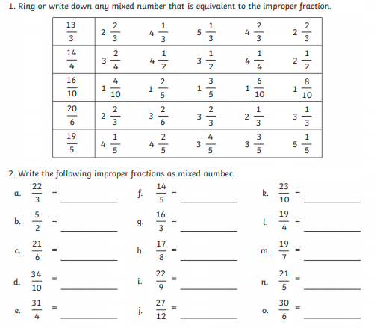
Write the following improper fractions as mixed number.

