Maths
- This table shows the weight of some fruits and vegetables.
Complete the table.
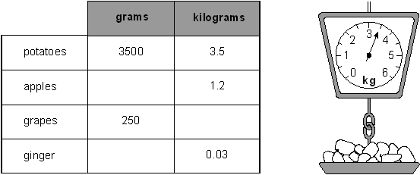
2)
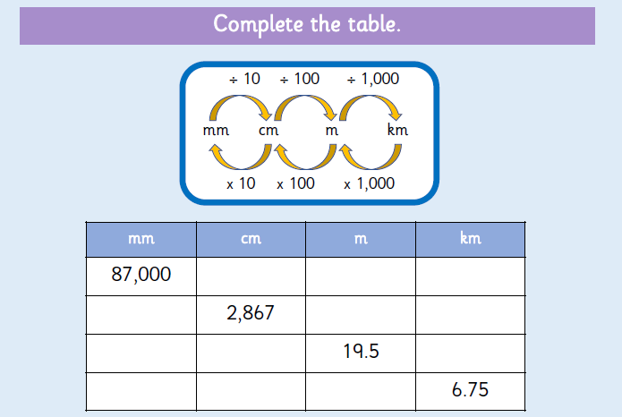
- Order the following lengths from smallest to largest:
9.4cm | 937mm | 0.4m | 39mm
2.5km | 2750m | 637cm | 148mm

- The red jug holds 1800 ml of water.

- The green jug holds 3/10 more. How much does the green jug hold?

________________________________________________________

- The blue jug holds 45% more. How much does the blue jug hold?

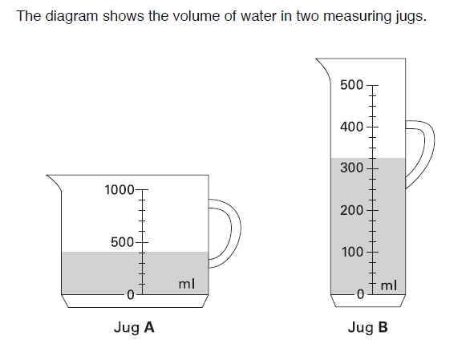
5A) Which jug holds the most liquid?

__________________________________________________________________
5B) How much more liquid does it hold?

__________________________________________________________________

