Learning intention- to recognise equivalent fractions.
Here is a fraction wall.
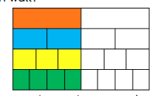
How many fractions are equivalent to one half?
Can you draw anymore rows to show more equivalent fractions?

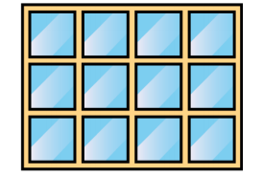
Look at this picture, how many equivalent fractions can you see?

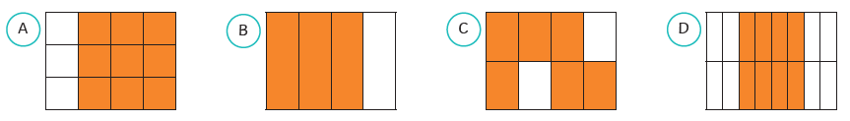
Which one of the shapes is the odd one out? Can you explain why?

