Spelling and vocabulary – Fill in the grid with all of the words on the right. Use the clues below to help you.

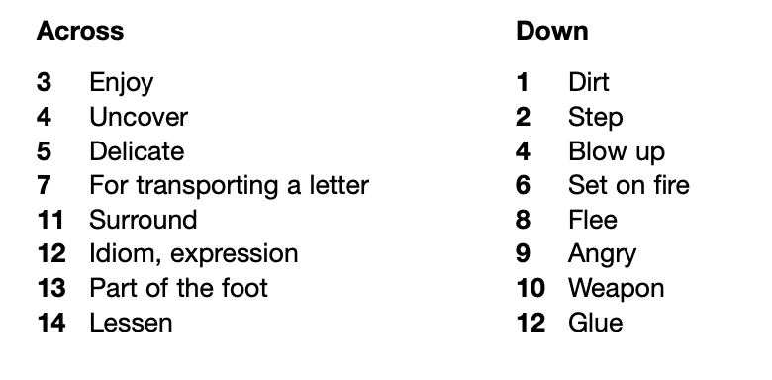
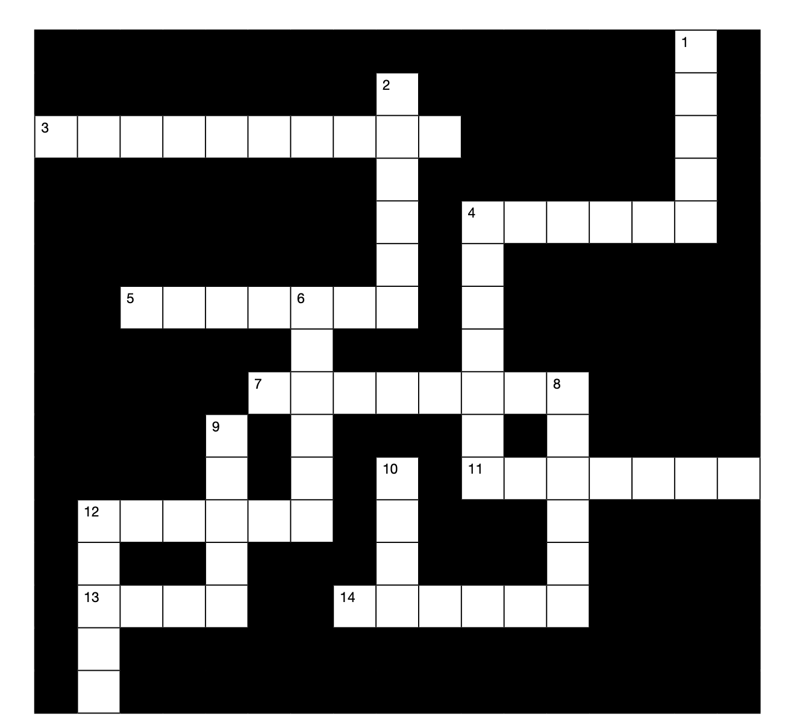
To help you – 3 across – if you enjoy something, you appreciate it.

