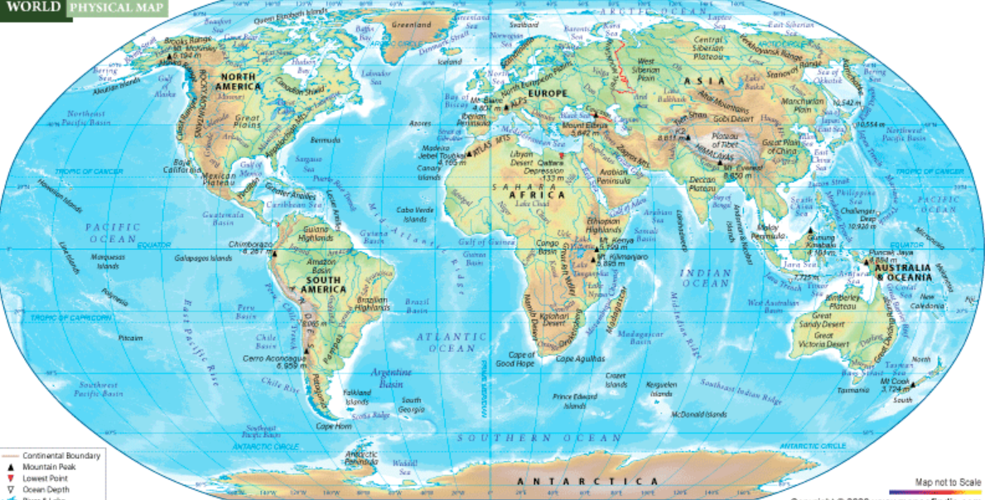
Geography Alternative learning- Map of the world

