Science
LO: To describe the life cycle of a frog
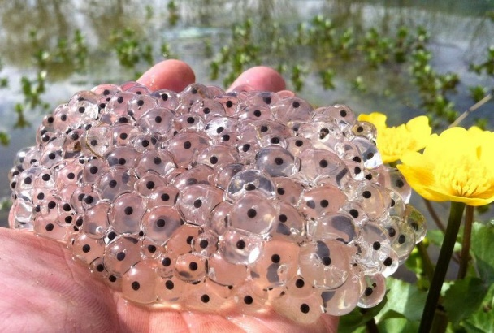
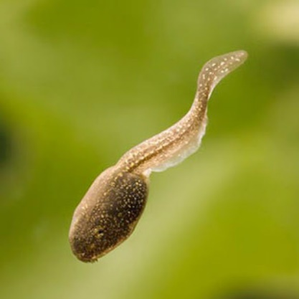
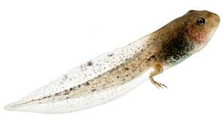
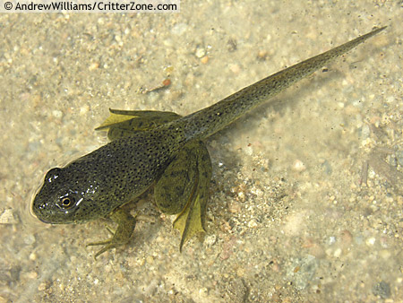
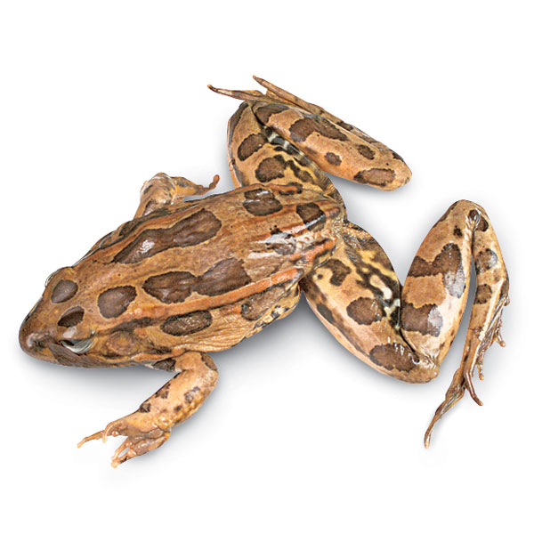

In summer, the tadpoles grow little legs.

In spring, frogs lay eggs in a blob of clear jelly called ‘frogspawn’.

Finally, the froglets turn into large frogs and have no tail. They will soon have their own babies and the cycle will start again.

After a few weeks, the frogspawn hatch and turn into tadpoles with a long tail to swim.

When it is twelve weeks old, they turn into a froglet and look more like a frog.

