Describe a character and setting.
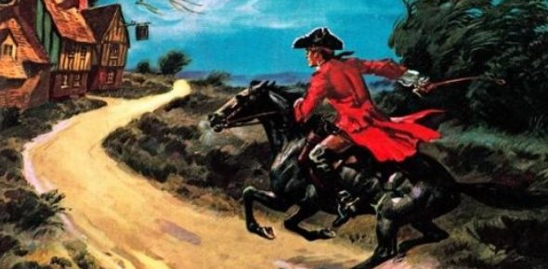
Look at the image below. Write as many words you can think of to describe what you can see.

