Science Task
Light
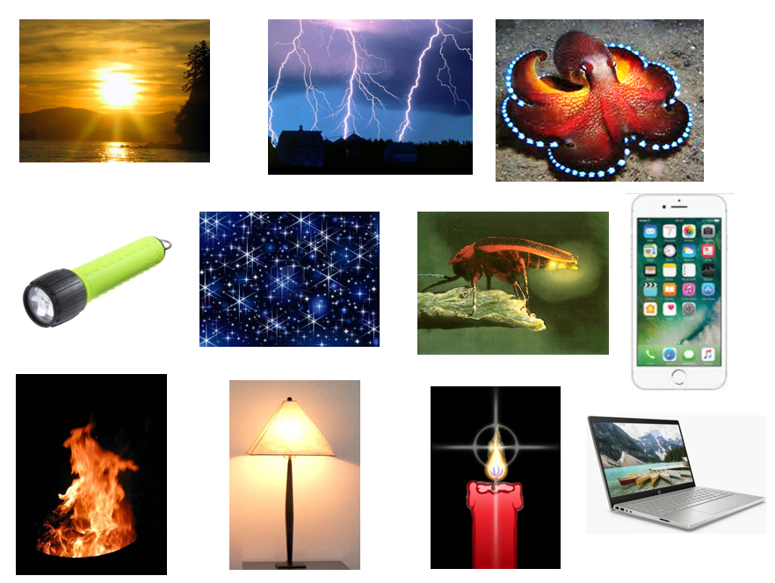
Sort these sources of light into manmade and natural sources of light in the grid below.
Can you add five more sources of light from around your home. Are they mostly man made of natural sources of light?
Natural sources of light | Manmade sources of light

