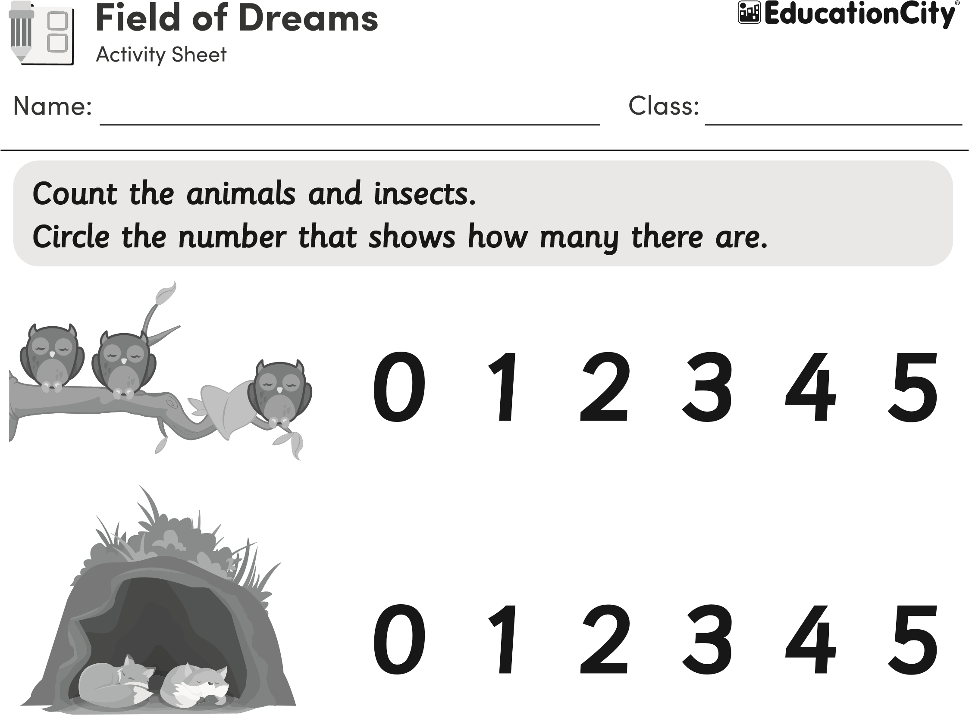
0 1 2 3 4 5
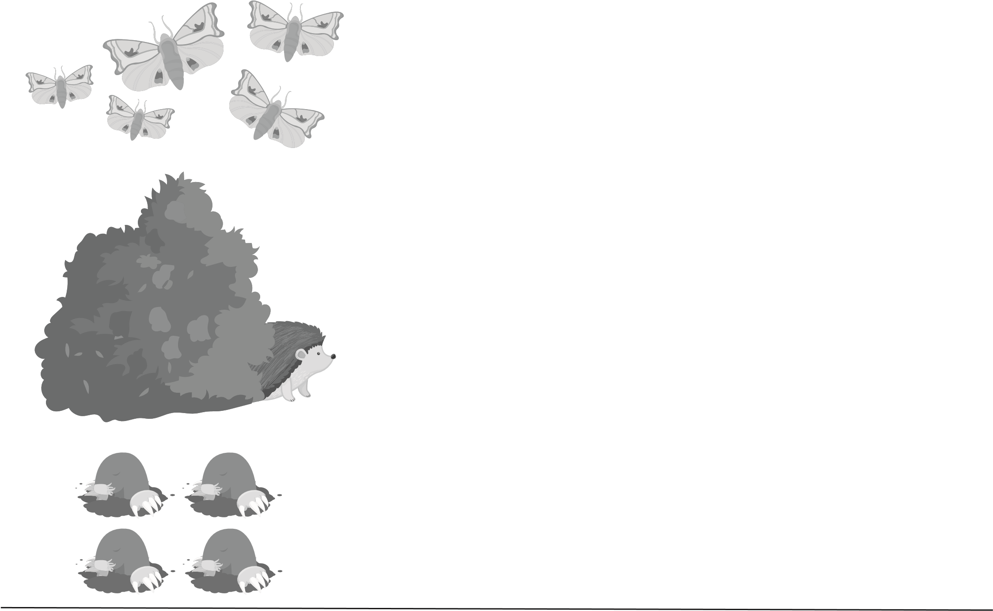
0 1 2 3 4 5 0 1 2 3 4 5
© EducationCity Ltd This may be reproduced for class use within current subscriber institutions.

