3D shapes worksheet
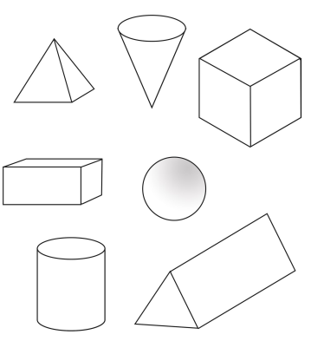
Have a look around you, colour in the shapes if you can see them.

