Start of the day – Pat your head while you rub your tummy for 30 seconds. Then swap hands. Which was easier?

Task one – Maths
Links - maths – TTRockstars
https://play.ttrockstars.com/auth
Education city - https://go.educationcity.com/

Task one – English https://www.oxfordowl.co.uk/
Education city - https://go.educationcity.com/
BBC Bitesize https://www.bbc.co.uk/bitesize/levels/z3g4d2p

Task one – Geography
BBC bitesize- https://www.bbc.co.uk/bitesize/topics/zx72pv4/articles/zrbvjhv

Remember school website is:
If stuck email Linda.hall@moorside.newcastle.sch.uk or
admin@moorside.newcastle.sch.uk

Reading
Choose one of the books you have been reading and compare it to another book you have read.
What is similar and what is different? Think about characters, settings and themes. You could use a venn diagram to compare if you wish.

Task one – English
- CGP GPS Basic Relative Clauses
- CGP English Autumn Term Workout 7

Foundation subject
Identify the different resources needed for a human to create a settlement. E.g the need for water.
Rank your list explaining what you think is the most important.
Here is a table to show Year 5’s favourite flavour of ice cream:

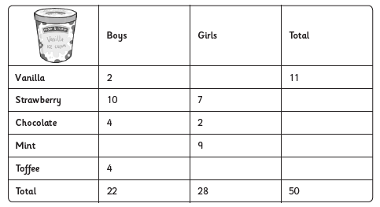

Use the information in the table to fill in the missing gaps

