Explain my ideas using evidence from the text
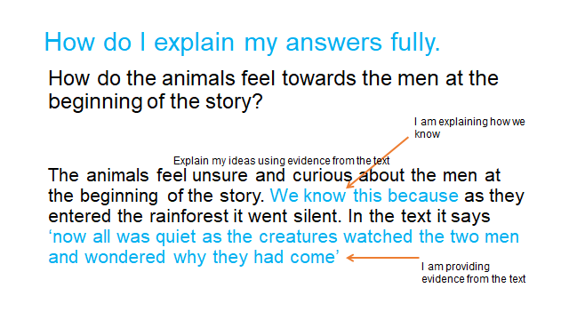

How do they feel towards the woodcutter who is sleeping?

Why do you think the three-toed sloth was only reaching the ground now?

The animals believe that the earth will be destroyed. How do we know that? What evidence in the story is there to support this view?

