Alternative 2- Identify turns and movement

Key vocabulary

Left right forwards backwards up down

What direction is each shape moving in?
1. 2.
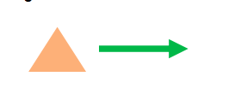

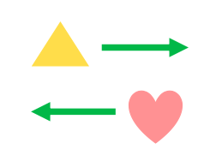
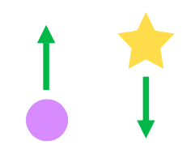
3. 4.

Now complete these sentences using the key vocabulary

