Maths Learning Intention - To find pairs of numbers that give an answer to an equation.

- ‘r’ stands for a number in row 1. ‘w’ stands for a number in row 2. Join all pairs of numbers that match this rule: 3r – w = 5. One is done for you.

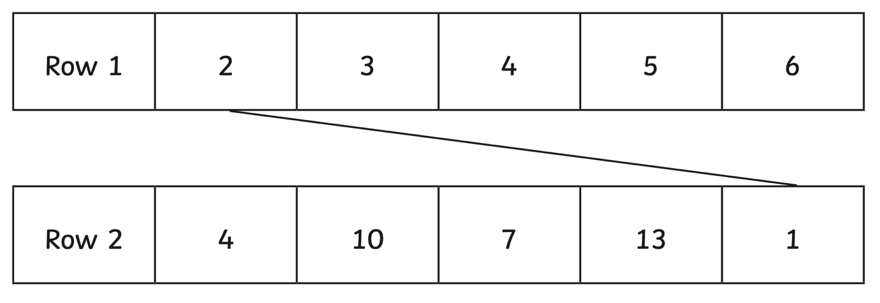

So if 3r – w = 5. In the example, 3 x 2 (from row 1) = 6 – 1 (from row 2) will equal 5.

- Here is an equation.

h = 250 + 3n

- Find the value of h when n = 25.

- Find the value of n when h = 400 (use your knowledge of the inverse operation here)

- I paint a picture using two colours. I have four colours to choose from: red, purple, gold and blue. My paintings could be:

Red and purple
Red and gold
Red and blue
Purple and gold

Write the two missing combinations.

- Here is a rule for the time it takes to cook an apple pie.

Cooking time = 15 minutes + 8 minutes for each 500g of chopped apples.

How many minutes will it take to cook a pie which uses 750g of chopped apples?

- A shop prints posters. They use this formula to work out the price for printing a poster:

Price = (£1.20 x number of colours) + £2.

- What is the price for printing a design that has three colours in it?

- I have £10 to spend on printing a design. What is the greatest number of colours I can have in my poster?

- Each shape stands for a number,

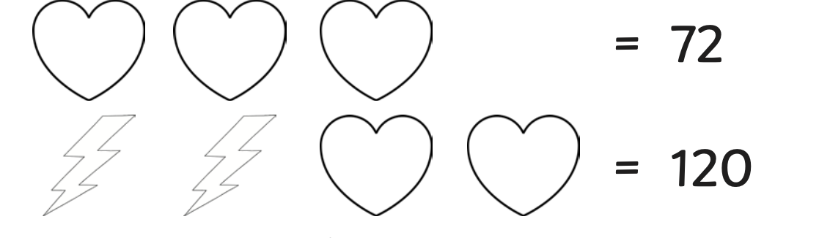

Calculate the value of each shape.
=

=

