1 Less Than (1-5)
Use these numbers to help you. Draw the object in the box.
1 less than 2 =
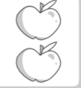
1 less than 5 =
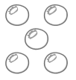
1 less than 3 =
1 less than 4 =

