Alternative learning – full stops
Add a full stop to the ends of the sentences. Look at the example to help. See how many tricky red words you can read!

I can do a full stop .

We go to the shop
My mum has a bag and it is big
I get a box of dolls and a red lollipop
Then I go to school and do my maths
I am having the best day with my friend

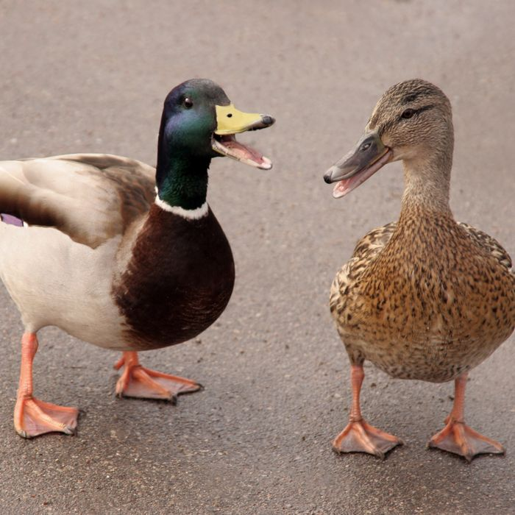
Can you write your own sentences about these two pictures? Remember your full stops.

___________________________________________________________________________________________________________________________________________________________________________________________________

