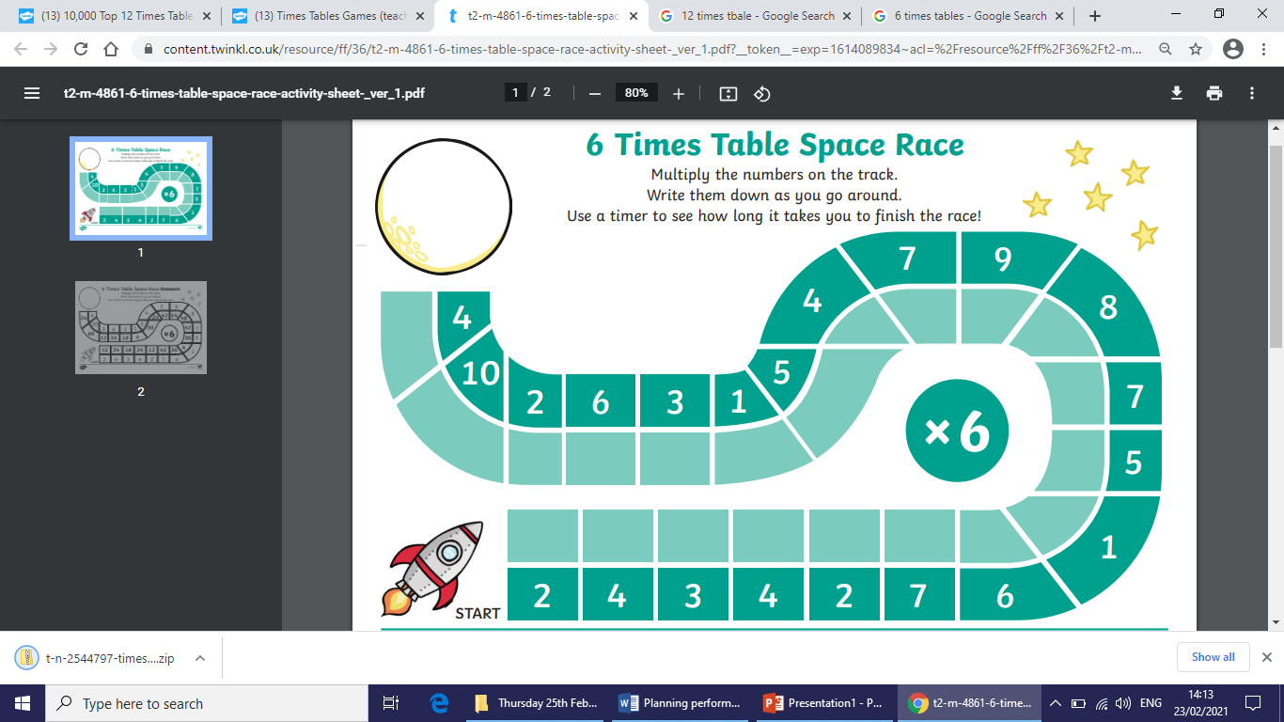

6 times table space race!



12 times table space race!