Alternative English- Plan a story
Have a look at the picture below. Discuss with somebody at home where Mr Fox might be going.
- Where do you think Mr Fox is?
- Where could he be going?
- How has he got there?

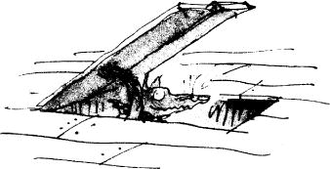
What happens next?
Use the blank story map below and draw what you think might happen next, after this picture.
Remember to use your imagination!
Start

End

