Orange and yellow
Read the diary entries from Tyler to find out more about countries in North America
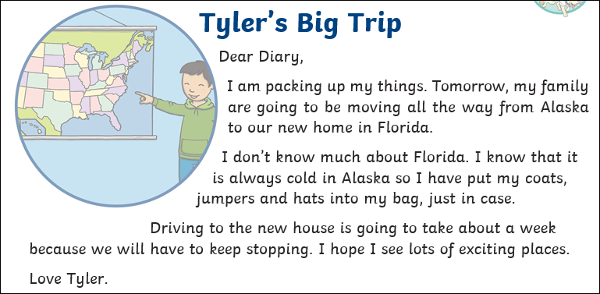
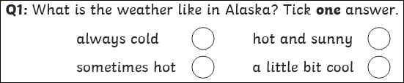

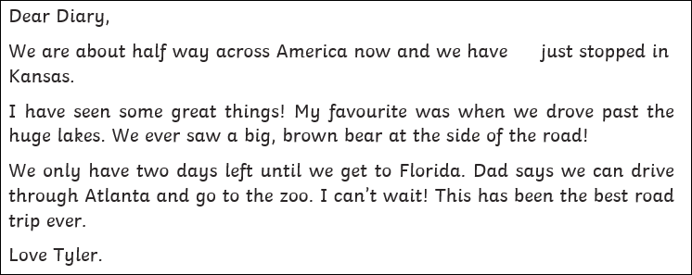
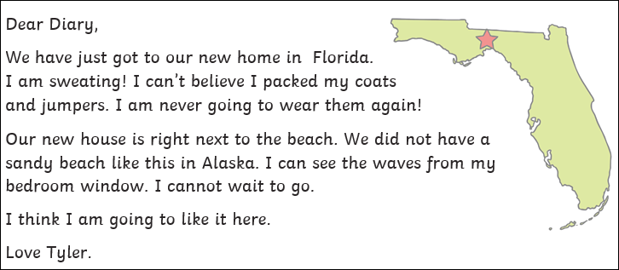
What is the weather like in Florida? How do you know?

