To learn about music from the past

Can you tell me three facts you have found out about these three famous musical artists of the 1970’s?
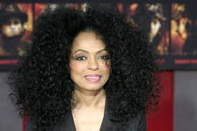
Diana Ross

……………………………………………………………………………………………………………………………………..

………………………………………………………………………………………………………………………………………

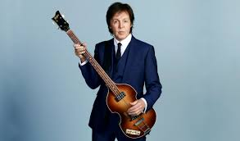

Paul McCartney

……………………………………………………………………………………………………………………………………..

………………………………………………………………………………………………………………………………………

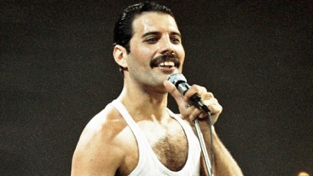
Freddie Mercury

……………………………………………………………………………………………………………………………………..

………………………………………………………………………………………………………………………………………

