Adjectives

Remember, an adjective is describing word. It is used to describe a noun.

For example:
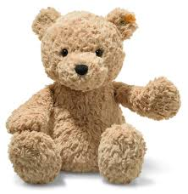 A soft teddy bear.
Soft is the adjective because it is describing the teddy bear.
Teddy bear is the noun because it is a thing.

Have a look at the words below, circle the words which are adjectives. I have done one for you.

red dog happy big

tree pink cat fat

Now have a look at the pictures below. Write an adjective on the line for each of the pictures, to describe the picture.
I have done one for you.


  

