Year 2 (Wednesday 3.3.21)
Exercise
Here are four yoga poses – Tree pose, Child’s pose, Frog pose and Warrior 3 pose. Try each one – for which one can you hold still the longest? Try your favourite one again and see if you can beat your time. 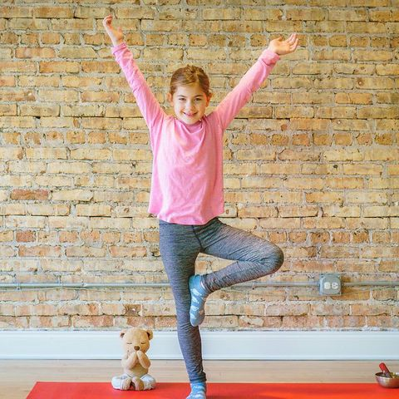 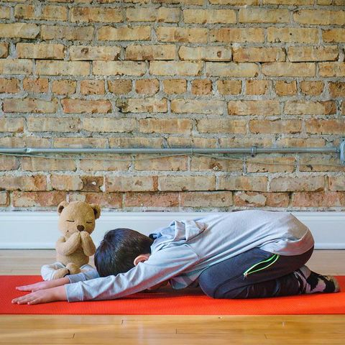 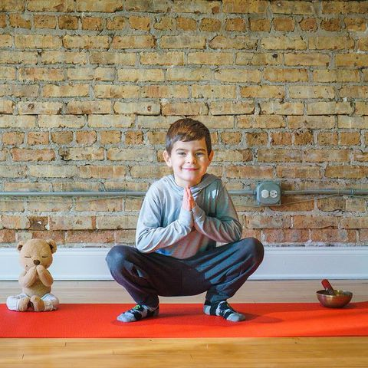
English
Learning intention: to plan instructions.

Use the PowerPoint to help you to think of instructions for an adventure. Then create your own story map for instructions in your book.

Alternative 1: Use the PowerPoint to help you to think of instructions for an adventure. Then complete your own story map for instructions on the sheet.
Alternative 2: Use the PowerPoint to look at instructions for an adventure. Then complete your own story map on the sheet.

Spelling: friend school everybody

Handwriting: using the PowerPoint, practise writing ‘ear’. Alternative 1: practise writing ‘ow’. Alternative 2: practise writing ‘e’.

Reading
Blue and grey: Read the text again. Look at the worksheet, match the words to the correct meaning.
Orange and yellow: Read the text again then answer the questions about the book on the worksheet.

Alternative reading
Pink and purple: Read the story again and answer these questions. You do not need to write the answers down, talk to an adult about them.
Red and green: Use the PowerPoint to read or listen to the teacher reading the story ‘I can hop’.
Maths
Learning intention: to solve multiplication and division problems.

Use your knowledge of solving multiplication and division problems to answer these questions. Use some of the methods we have looked at this week to help you. Remember to write the calculation not just the answer.
Alternative 1: Use your knowledge of multiplication and division to solve these problems. Use some of the methods we have looked at this week to help you. Write the calculation.
Alternative 2: Use your knowledge of counting in 2’s, 5’s and 10’s to help solve these problems.

Geography
Learning intention: to explore physical features of Europe.

Look through the PowerPoint then complete the Europe fact hunt using the maps on the sheet. If you need a reminder about physical features, look at this link: https://www.bbc.co.uk/bitesize/topics/zqj3n9q/articles/zr8q7nb

Alternative 1: Listen to the PowerPoint then find the European physical features using the clues.
Alternative 2: Listen to the PowerPoint then look on the maps to explore the mountains, rivers and seas you saw.

Remember school website is: http://www.moorside.newcastle.sch.uk/website
If stuck or want to send completed work then email linda.hall@moorside.newcastle.sch.uk

