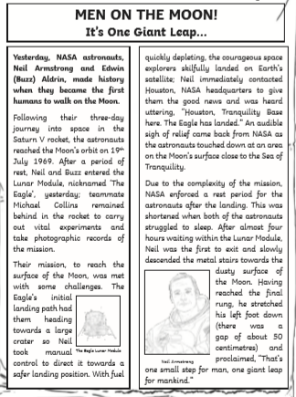
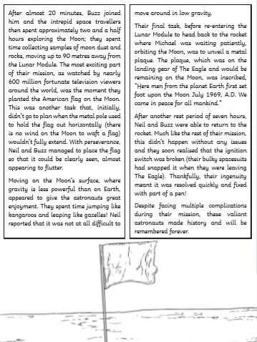
English
- How can you tell that this is a newspaper report?

- Who were the first astronauts to walk on the moon?

- When did they walk on the moon for the first time?

- How long did the journey to space take the astronauts?

- Why did Michael stay behind in the rocket?

- Look at the second paragraph. Find and copy one word meaning ‘brave’.

- What do you think Neil Armstrong’s famous saying means “That’s one small step for man, one giant leap for mankind”?

- How many people watched the event on television?

- What did the astronauts do to explore the different gravity on the moon?

- Order these statements to show the order in which they happened.
- Neil and Buzz used a pen to fix the ignition switch.
- Neil contacted NASA headquarters to let them know they had landed safely.
- Neil stepped onto the surface of the moon.
- The astronauts travelled in the Saturn V rocket to the moon.
- After twenty minutes, Buzz joined Neil.
- They planted an American flag on the moon.

