Year 1 Learning (11.02.21)
Motor skills  - Have a go at the Honeybee Maze worksheet  - Do 10 toe touches slowly and safely  - Do 20 arm circles |  | 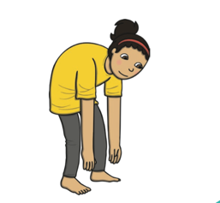 | 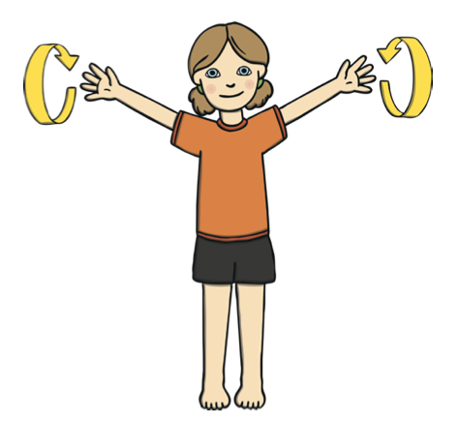
English
Learning intention: To retell a traditional tale.
- Look at yesterday’s PowerPoint and listen to how we retell using the story map.
- Can you use your story map to retell the story with your new character(s)?
- Phonics: ar
- Handwriting: ar

Alternative English:
- Look at yesterday’s PowerPoint and listen to how we retell using the story map.
- Can you use your story map to retell the story with your new character(s)?
- Phonics: h
- Handwriting: n
Maths
Learning intention: To recap numbers
- Go through the PowerPoint and see if you can guess the numbers from the clues.

Alternative maths 1
- Go through the PowerPoint and see if you can guess the numbers from the clues.

Alternative maths 2
- Go through the PowerPoint and see if you can guess the numbers from the clues.
Foundation - RE
Learning intention: To explore the story and celebration of Chinese New Year

Chinese New Year is special to many people. Go through the PowerPoint and listen to the story.
Can you answer the questions about the story?

Watch the videos to show how Abbie’s family celebrate Chinese New Year: https://www.bbc.co.uk/cbeebies/watch/chinese-new-year?collection=chinese-lunar-new-year
Reading:  Join in with the story ‘Little Black Hen’ on Education City.  https://go.educationcity.com/content/index/42171/3/1/1/null/null/false/false/null/0  What was your favourite part?  Who is your favourite character?  Why? | Remember, the school website is:  http://www.moorside.newcastle.sch.uk/website  If you are stuck or want to send completed work then email:  linda.hall@moorside.newcastle.sch.uk

