1 Less Than
Use these numbers and objects in the classroom to help you.
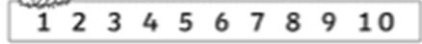

1 less than 3 =

1 less than 9 =

1 less than 7 =

1 less than 5 =

1 less than 10 =

