Alternative History – To know the difference between invaders and settlers.

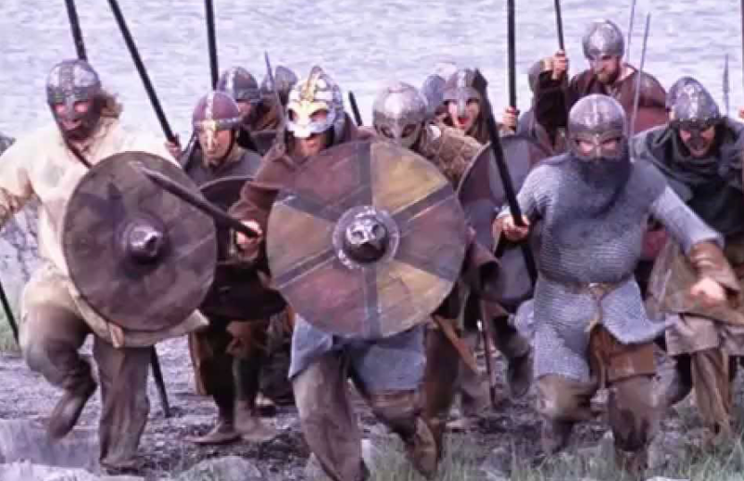
Do you think the images below are invaders or settlers? Why?

__________________________________________________________________________________________________________________
__________________________________________________________________________________________________________________






