Start of the day – What are your balancing skills like? Try standing on one leg for a minute. Then swap to the other leg. Which one was easier?

Links - maths – TTRockstars
https://play.ttrockstars.com/auth

Task one – Maths

Task one – English
- CGP GPS Pronouns
- CGP English Spring Term Workout 5

Remember school website is:
If stuck email Linda.hall@moorside.newcastle.sch.uk or
admin@moorside.newcastle.sch.uk

History Links
https://www.bbc.co.uk/teach/class-clips-video/history-ks2-introducing-ancient-sumer/zmgnvk7

Task one – English https://www.oxfordowl.co.uk/
Education city - https://go.educationcity.com/
BBC Bitesize https://www.bbc.co.uk/bitesize/levels/z3g4d2p

Reading
Read one of your books. Choose a character and describe how their feelings change at different points in the story.
How are they feeling and why?
Find a sentence as evidence that they are feeling that way.

History
Ancient Mesopotamia was a very advanced civilization and they invented their own form of writing – cuneiform. Use the cuneiform translations to write your own words and sentences for someone else to decode.
Task one
Complete these number sentences.
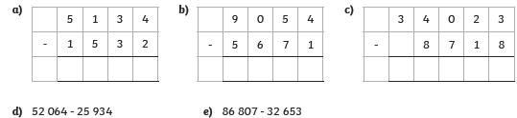

Task two
Here are the flight times, in seconds for each flying team.
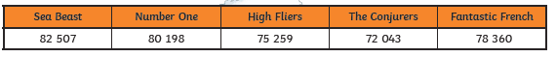
a) Which team had a difference of 3101?
b) Which two teams have the greatest difference? Prove it!

