Alternative English- Role Play
Today you are going to play the role of different characters from Fantastic Mr Fox (chapters 1-3).
Have a look at the list of characters below and get into character by imagining you are that person.

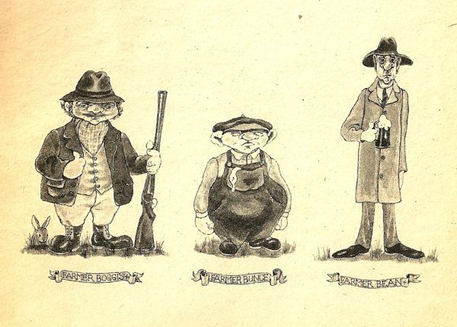

Mrs Fox Mr Fox Boggis Bunce Bean Mr and Mrs Fox’s children

Now ask someone in your house to role play with you. Imagine you are one of the characters from the story and someone in your house is another character. Role play the different parts of the story so far by acting and talking in the role of the character.
Remember to use your voice in different ways!
Here are some examples of the different parts of the story that you could role play:

Role play ideas

- Mr and Mrs Fox in their home.
- Mr Fox going out of the home to find food.
- Boggis, Bunce and Bean discussing Mr Fox.
- Mr Fox and one of the farmers having an argument.
- Mr and Mrs Fox’s children playing in their home.
- Mr Fox exploring the farms for food.
- Mrs Fox cooking the food that Mr Fox has brought home.
- Boggis, Bunce and Bean waiting to shoot Mr Fox’s tail.
- Mrs Fox helping Mr Fox after his tail has been shot.

