Geography
Here is a map of part of Newcastle. What can you identify from the map? Can you see any houses or factories? Could you label what you see?

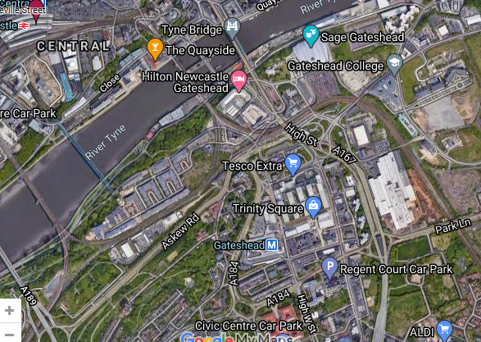
houses

hotel

Here is a map of areas outside of Newcastle? What do you notice? Are the settlements smaller? Do you think Whickham is a town or village? Why?
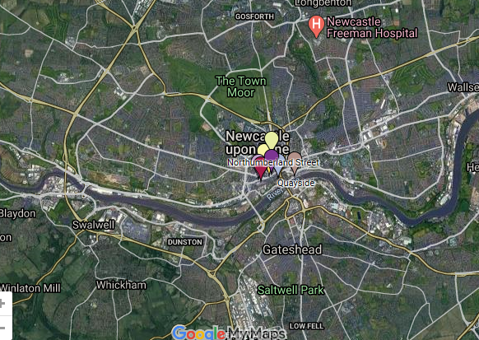

How do you think people will travel to these rural areas from the towns and cities?

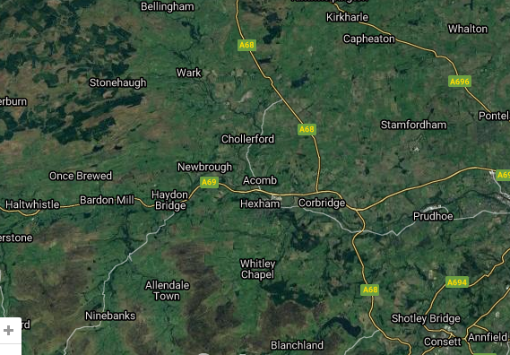
Here is a map of Bamburgh. What can you see on the map? Do you think Bamburgh is a hamlet, a village, a town or a city?
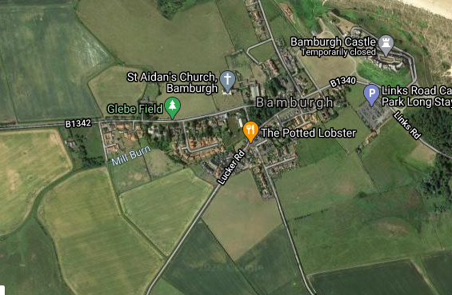

Here is a map of Sinderhope in Northumberland. What type of settlement do you think this is? Why?

