Year Four Learning (05.02.21)

Exercise
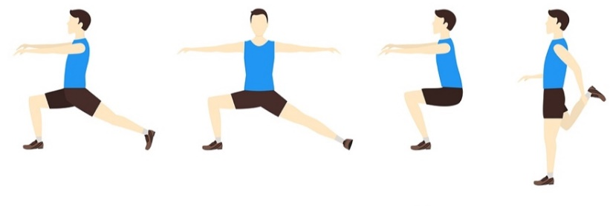
Here are 4 more stretches and balances for you to try. You are going to do each stretch 3 times.

After each try, have a short rest. The next time you do the stretch you should be able to stretch even further.

English – Learning Intention: To use descriptive language to improve my work.
You are going to be given a paragraph, written in the style of ‘The Great Kapok tree’. This is a very simple paragraph with no expanded noun phrases or exciting vocabulary choices. I would like you to read the text then re-write it to improve it with expanded noun phrases and some more interesting vocabulary choices.

Alternative 1 – Learning Intention: To use descriptive language to improve my work.
You are going to be given a paragraph, written in the style of ‘The Great Kapok tree’. This is a very simple paragraph with no expanded noun phrases or exciting vocabulary choices. I would like you to read the text then re-write it to improve it with expanded noun phrases and some more interesting vocabulary choices. I have underlined some sections where I think you can improve it but I’m sure that you can fine even more area that you can develop.

Alternative 2 – Learning Intention: To use descriptive language to improve my work.
You have been practicing adding adjectives to sentences for the last two days. Today you are going to be given some images and I would like you to create your own sentence about what you can see in the picture. Thinking carefully about full stops, capital letters and those adjectives we have been practicing. There is a PowerPoint that you should look at which will help you.
Maths – Learning Intention: To find fractions of amounts
You have worked hard this week to solve problems involving fractions of amounts. You are going to have to think about everything we have done over the past few days to solve some different reasoning and problem-solving questions all about fractions of amounts. Read each question carefully and think about how you would solve it.

Alternative 1 – Learning Intention: To find fractions of amounts
You have looked carefully at how to find unit and non-unit fractions of amounts this week. Read through the PowerPoints from the last two days carefully to remind yourself how find unit and non-unit fractions of amounts then try to solve the word problems on the attached sheet.

Alternative 2 – Learning Intention: To find fractions of amounts
Yesterday you practiced finding ¼ of an amount practically. Today you will be looking at how to solve questions about ¼’s. Read through the PowerPoint carefully and then answer the questions on the sheet.
Music – Learning Intention: To learn about music from the past
You have been learning about some different music from the 1970’s this week. We are going to continue this today, but we are going to look at more detail into three famous music artists from this era. You will have to read about them and then I want you to tell me three interesting facts that you have learnt about each artist. You could also do some of your own research into these artists where you might be able to find out some facts that I didn’t know!

Alternative 1 – Learning Intention: To learn about music from the past
You have been learning about some different music from the 1970’s this week. We are going to continue this today, but we are going to look at more detail into three famous music artists from this era. You will have to read about them and then I want you to tell me three interesting facts that you have learnt about each artist. You could also do some of your own research into these artists where you might be able to find out some facts that I didn’t know!

Alternative 2 – Learning Intention: To learn about music from the past
You have been learning about some different music from the 1970’s this week. We are going to continue this today, but we are going to look at more detail into three famous music artists from this era. You will have to read about them and then I want you to tell me one interesting fact that you have learnt about each artist. You could also do some of your own research into these artists where you might be able to find out some facts that I didn’t know!

Reading  You have a PowerPoint for the next part of the Oh Otto story. As you read through the story there are questions for you to try and answer.  Alternative Learning  Open the book ‘ Get Up!’ on Oxford Owl, here is a link  https://www.oxfordowl.co.uk/api/interactives/29262.html  Read the story again to someone in your house. Then can you practice writing your green words then read them again.  RWI Green  Open the book ‘Hands’ on Oxford Owl, here is a link  https://www.oxfordowl.co.uk/api/interactives/29268.html  Read story again to someone in your house. How many words can you find the with ‘sh’ or the ‘ng’ sounds? Are there any words that have both sounds?  RWI Purple and Pink  Open the book ‘Sam’s Bag’ on Oxford Owl, here is a link  https://www.oxfordowl.co.uk/api/interactives/33866.html  Read story again to someone in your house. Have a think and pretend you were going to go and stay at your grandparents house. Is there anything you would pack that is the same as Sam?  RWI Orange and Yellow  Open the book ‘What’s in the woods’ on Oxford Owl, here is a link  https://www.oxfordowl.co.uk/api/interactives/29303.html  Read story again to someone in your house. How many words can you find that have a double vowel in them (oo, ee)?  RWI Blue/Grey  Today we are looking at the book ‘The ice and snow book’ on Oxford Owl., here is a link https://www.oxfordowl.co.uk/api/digital_books/2092.html  Read story again to someone in your house. Can you find how many words have 2 syllables in them and how many have 3 syllables in them? | Remember school website is:  http://www.moorside.newcastle.sch.uk/website  If stuck or want to send completed work then email  linda.hall@moorside.newcastle.sch.uk

