Geography task
Label the map of Europe below using the list of countries to help you.
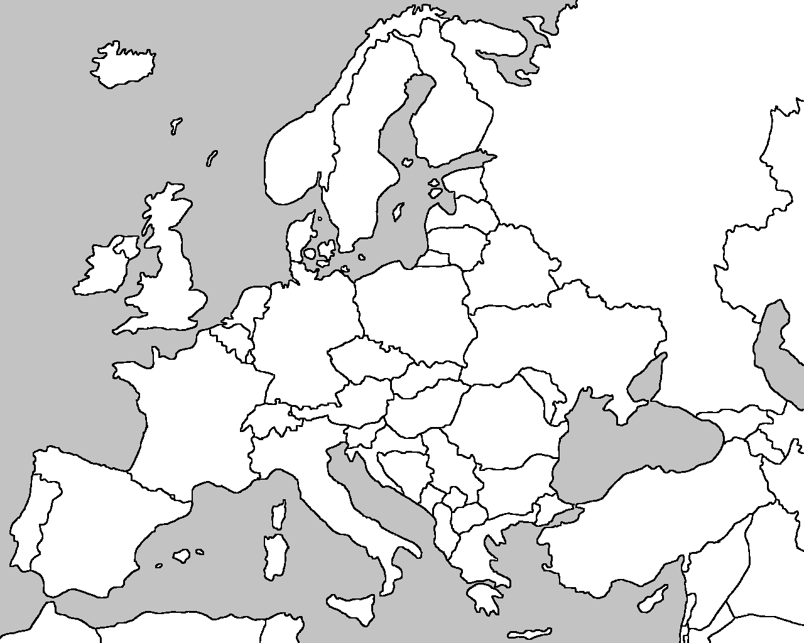

Netherlands Spain Portugal Greece
Russia England Italy Poland

Hungary Turkey Romania Ireland

History task
