Playgroup and Nursery Learning
For Week 01/03/2021

Physical and emotional development – At different points throughout each day with someone in your family spend time working on the Magic Beans activity and carry out the different actions linked to the beans. Take care and make sure you have enough space to do these actions.

Like last week, we have more Yoga exercises – remember that Yoga is a way to exercise our bodies, our breath, and our minds all at the same time. It is important to remember to breathe in through our noses and out through our mouths slowly and carefully whilst we try to stay in position with the exercise for a few seconds. Try these different positions each day this week, count to six each time whilst you stay in the position before the next one. As you get towards the end of the week, see if you can count more than six as you hold the position. Remember to do your breathing each time. You have two sets of exercises try one and then the other the next day then over the week change which ones you do.

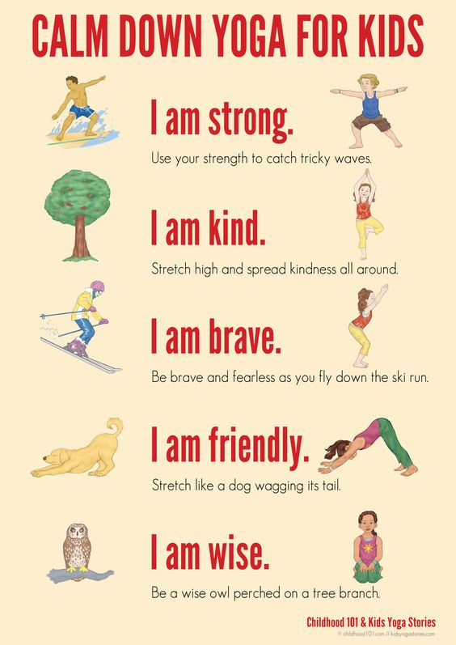
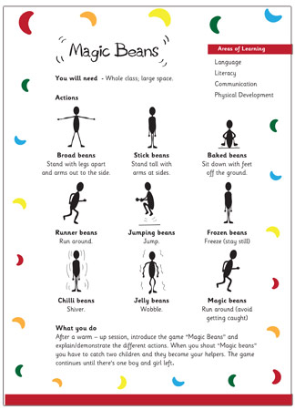

Literacy - Sharing a story
Use the PowerPoint with someone in your family and share the story called Big Bad Bug. Once you have shared the story chat with someone in your family about what happens in the story.
Can you retell the story to someone in your family? Talk about what happens first, next and then how the story ends.

Maths – Let us start with our counting from zero to ten using our fingers to help us.
- Follow the PowerPoint of Polar Bear Fishing and help him to count the fish
- Now use the PowerPoint to follow and sing Five Little Monkeys Jumping on the bed – show someone in your family the different actions to go with this counting song.

Handwriting
Follow the lines on the first sheet then do the second sheet in the same way by yourself and remember to try this with your fingers first before using a pen or pencil.

Songs and rhymes to learn:  - Follow the song for ‘Head Shoulders Knees and Toes’ and make sure you do the actions while you song.  - Do the same for ‘Here we go Round the Mulberry Bush’ – normally we do this holding hands in a circle see if you can do this holding hands with someone in your family.  - Use the PowerPoint to follow and sing ‘Old MacDonald had a Farm’. Try to put some actions into your rhymes as you sing them and the different noises the animals make. | Remember the school website is:  http://www.moorside.newcastle.sch.uk/website  If you are stuck or want to send completed work then email  linda.hall@moorside.newcastle.sch.uk

