Reading - The train to impossible places.
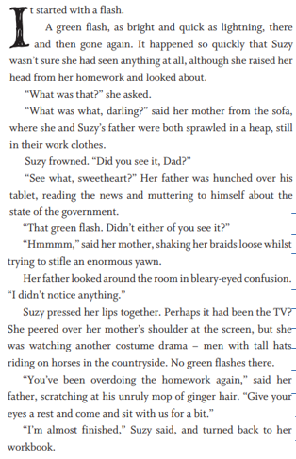

- Lookin at the title ‘The train to impossible places’, what do you think this book will be about?
- What does the word ‘Sprawled’ mean?
- What colour was the flash of light?
- Where were Suzi’s parents sprawled?
- What does the word ‘hunched’ mean?
- Select two phrases which shows the parents are tired.
- Find a synomyn for the word uncontrollable
- Do you think Suzi liked doing her homework? Explain your answer why.
- Can you describe dads hair?
- What was mother watching on the Television?

