Maths
Learning Intention: To translate shapes on a grid
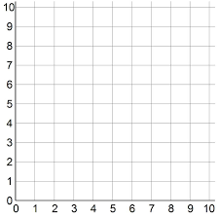
Translate this triangle 4 squares left.
Translate this square 5 squares up.
Translate this triangle 3 squares right.
Translate this rectangle 4 squares down.

