Day Two - History
What is it and what might it be used for?
______________________________________________
______________________________________________
______________________________________________

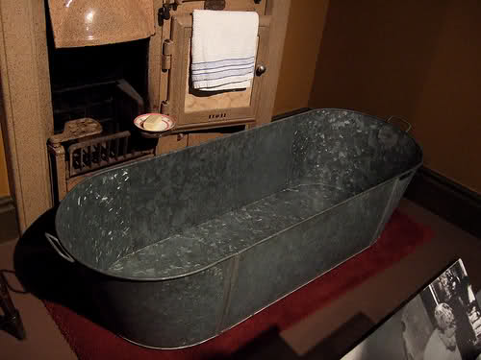
What is it and what might it be used for?
______________________________________________
______________________________________________
______________________________________________
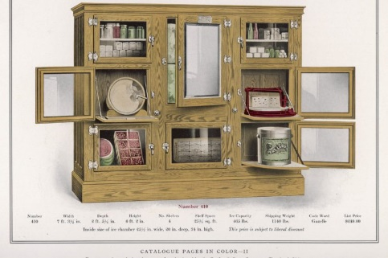
What is it and what might it be used for?
______________________________________________
______________________________________________
______________________________________________
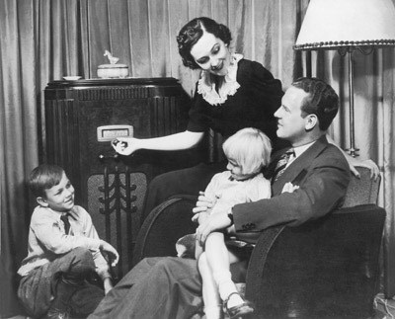
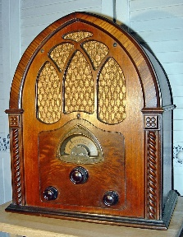
What is it and what might it be used for?
______________________________________________
______________________________________________
______________________________________________
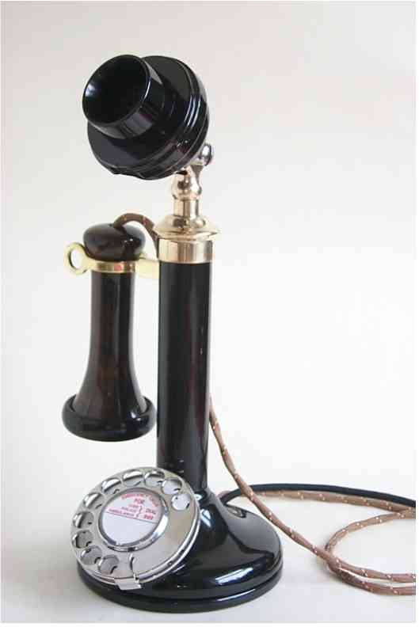
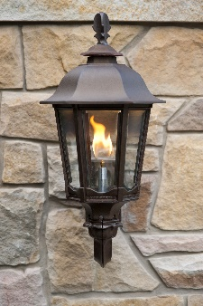
What is it and what might it be used What is it and what might it be used
for? for?
__________________________ __________________________
__________________________ __________________________
__________________________ __________________________

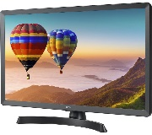

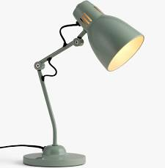
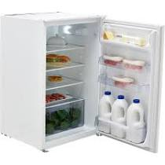
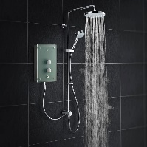
Extra support ideas

