Interpreting bar charts
Look at the bar chart and answer the questions to go with it.
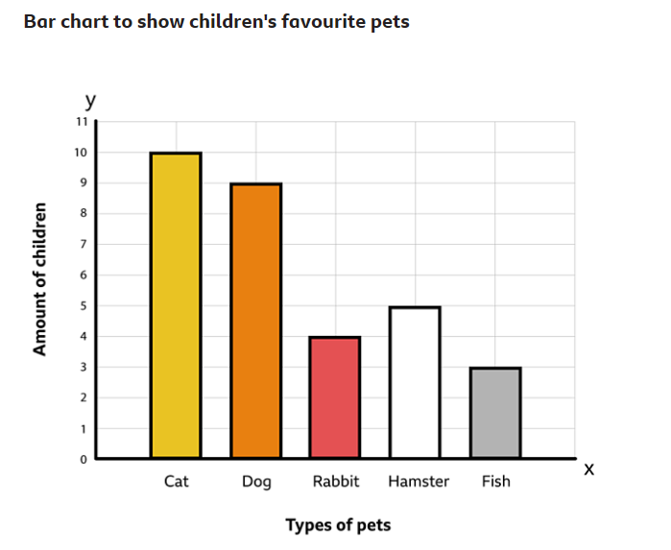
How many children chose a cat as their favourite pet?

How many more children chose a dog than a fish?

Which pet was the most favourite?

Which pet was the least favourite?

