Year 2 (25.2.21)
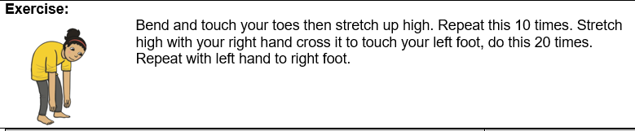
English
Learning intention: to explore features of instructions.

Use the PowerPoint to remind you about the features of instructions. You should have found imperative verbs, lists and use of the second person in the text yesterday. Can you find these features in the rest of the ‘Instructions’ text? Try to read the text on the sheet by yourself before listening to the teacher read the story.

Alternative 1: use the PowerPoint to remind you about the features of instructions. Can you find these features in the next part of the text? Listen to the teacher read the end of the story on the PowerPoint and find how many instructions there are. How can you tell a sentence is an instruction?
Alternative 2: listen to the rest of the story on the PowerPoint. How many imperative verbs can you spot? Try to act out some of the instructions as you listen.

Spelling: made make were

Handwriting: use the PowerPoint to practise writing the ‘ai’ sound. Alternative 1: practise the ‘oy’ sound. Alternative 2: practise the ‘k’ sound.

Reading
Blue and grey: read the story again then answer the questions on the sheet. Additional challenge: can you write a book review for ‘The Train of Fear’?
Orange and yellow: use the PowerPoint or Oxford Owl to read the story ‘Good Old Grandad’.

Alternative reading
Pink and purple: read the story again then answer the questions about the text.
Red and green: practise saying and writing the ‘ch’ special friend. Can you think of any words where you can hear this sound?
Maths
Learning intention: To make tally charts.
Look at the PowerPoint to learn about tally charts. Complete the worksheet.
Alternative 1: Use the alternative PowerPoint to learn about tally charts then complete the worksheet.
Alternative 2:. Use the alternative PowerPoint then complete the alternative 2 worksheet.

History Learning intention- To know about famous people.
Look at the pictures on the worksheet. They give us clues about who we will be learning about. Do you know who the person is? What tools can you see in the pictures? Predict why he might be famous.

Alternative: Look at the pictures on the worksheet. They give us clues about who we will be learning about. Do you know who the person is? What tools can you see in the pictures? Tell an adult why you think this person might be famous. .

Remember school website is:http://www.moorside.newcastle.sch.uk/website
If stuck or want to send completed work then email linda.hall@moorside.newcastle.sch.uk

