To identify what is the same and different about features of East London
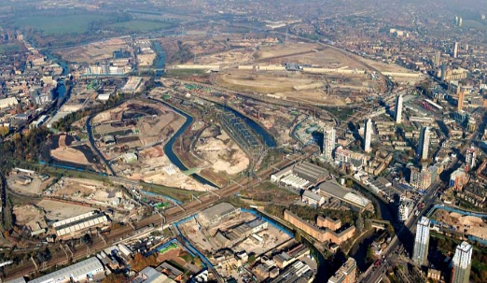
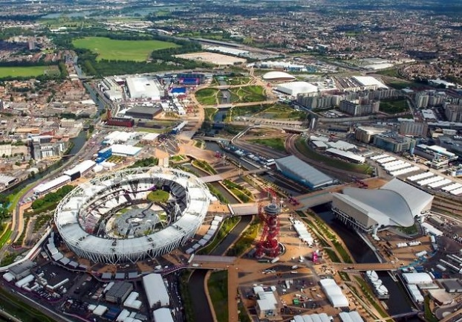

East London 2008 East London 2012

Can you identify what is the same and different about this part of London in 2012?

Human features in 2012 | Physical features in 2012

