Learning intention- To create a pictogram.
Look at the pictures and use this information to complete the tally chart.
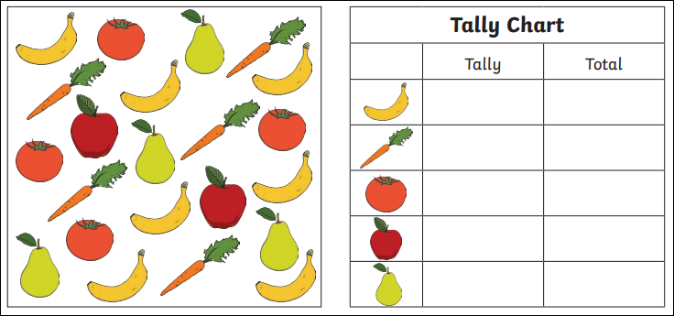

Now put this information into a pictogram. Draw a circle to represent each piece of fruit.
