Expanded noun phrases
Have a look at the pictures below. First, think of at least one adjective to describe each of the pictures.
Then put each adjective into an expanded noun phrase by adding an article (for example the, a or an) and a noun.
Adjective: ___________________________

Expanded noun phrase: _____________________________________________________
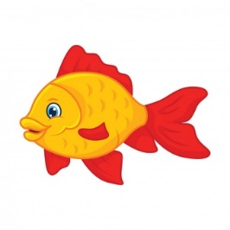
Adjective: _________________________

Expanded noun phrase: _____________________________________________________
Adjective: _________________________

Expanded noun phrase: _____________________________________________________
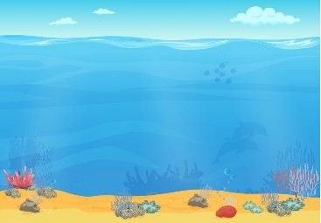
Adjective: _________________________

Expanded noun phrase: _____________________________________________________
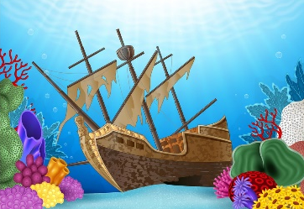

Now have another look at the picture that we will be using to write our story. Use some expanded noun phrases to write a setting description all about the picture.

Remember a setting description describes the location of the picture. Remember to use good punctuation and you could include some time conjunctions from yesterday’s work.

_________________________________________________________________________________

_________________________________________________________________________________

_________________________________________________________________________________

_________________________________________________________________________________

_________________________________________________________________________________

_________________________________________________________________________________

_________________________________________________________________________________

_________________________________________________________________________________

_________________________________________________________________________________

