To use descriptive language to modify sentences
Look at each of the animals and create sentences for each one using adverbials and adverbial phrases.
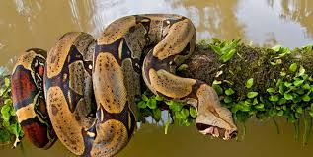
Here is an example using the
A poisonous, sleek snake slithered silently by.
Angrily, he hissed into the ear of the exhausted, sleeping man.
He slid down the rough, brown branches of the great tree.
