Reading

Read the sounds in and out of order.
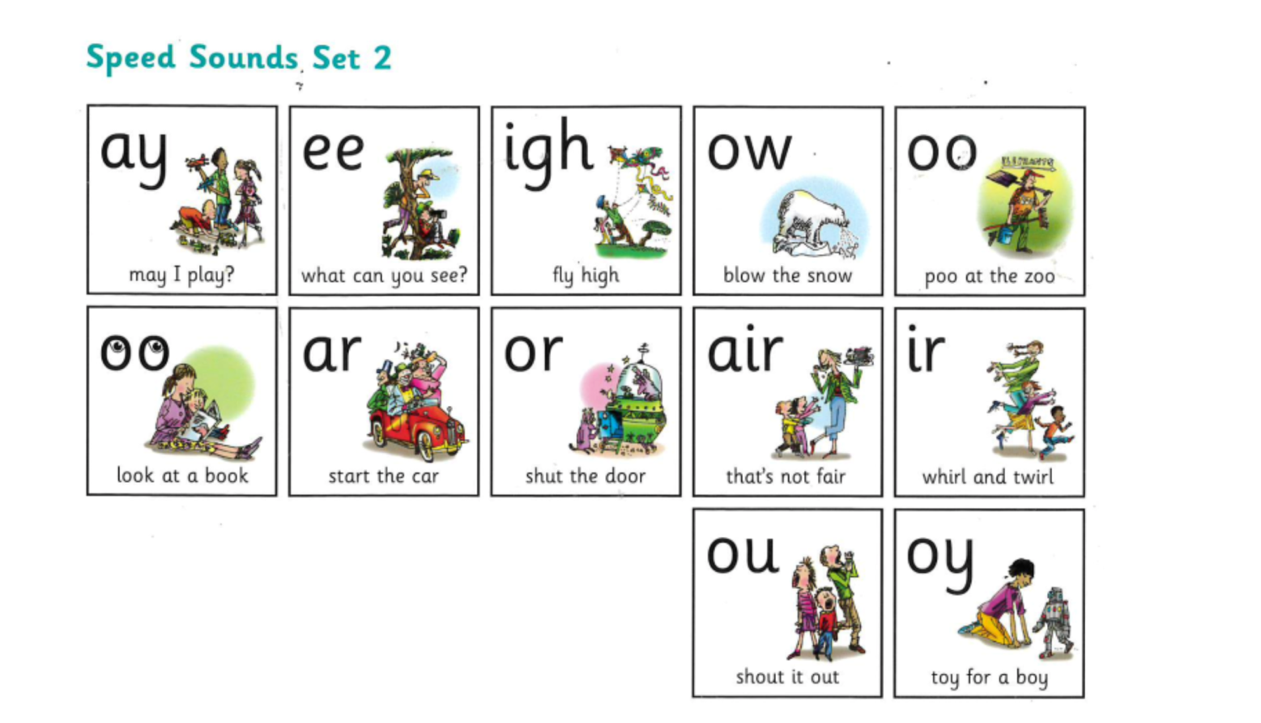

Challenge: Choose 4 sounds to think of as many words that have that sound in.

