Learning intention: To solve division problems.
Write the calculation and show how you solved the problem
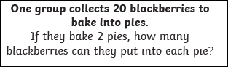

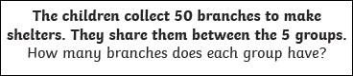

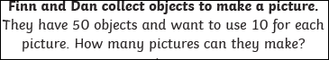

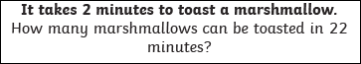

Challenge:
