Tuesday 26th January
To understand vocabulary.

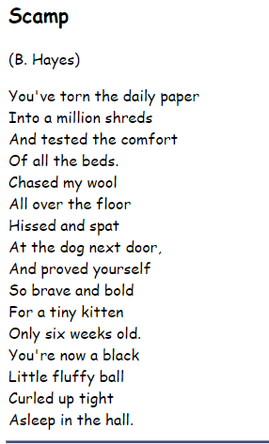

Can you circle any unfamiliar words in the poem? Rea the sentence and see if you can figure out what they mean. If you have a dictionary you could use that to help you.
Could you now circle any rhyming words?

Where are the rhyming words in the poem?
Are they at the beginning, middle or end of the line?

