Year 1 Learning (22.02.21)
Motor skills  - Wall push: Find a wall. How many arm pushes can you do in 1 minute (60 seconds)?  - Downward facing dog: Start on your hands and knees (breathe in), breathe out and push onto your toes so you look like an upside down v like the picture. Breathe in and out. Slowly go back to your hands and knees on the floor.  - Have a go at the Castle maze sheet. Try and stay in between the lines! |  | 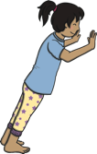 | 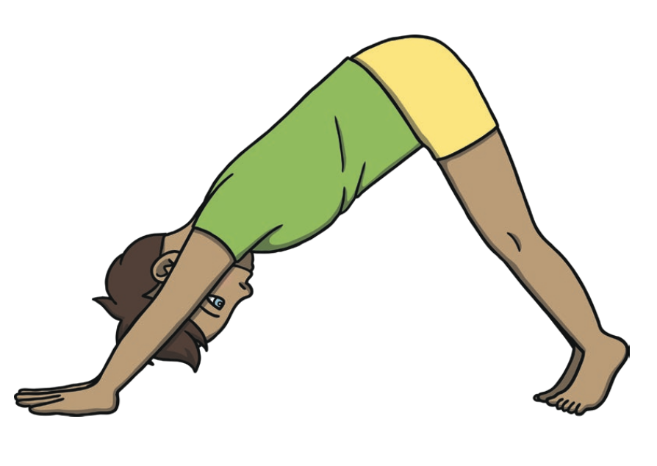
English
Learning intention: To recap ‘Peter and the Wolf’
- Go through the PowerPoint and have a go at finding the differences between the story maps.
- Phonics: air
- Handwriting: air

Alternative English:
- Go through the PowerPoint and have a go at finding the differences between the story maps.
- Phonics: r
- Handwriting: g

Alternative English 2:
- Go through the PowerPoint and have a go at finding the differences between the story maps.
- Phonics: r
- Handwriting: g

Maths
Learning intention: To learn about time
- Go through the PowerPoint about telling the time and see if you can choose the correct clocks for the times.
Alternative 1
- Go through the PowerPoint about day and night and tell your grown up if you do the activities in the day or at night.

Foundation - Music
Learning intention: To listen to the music and instruments from ‘Peter and the Wolf’

Go through the PowerPoint and listen to the different instruments. Talk about which one was your favourite and why.

Reading:  Read the Set 2 Green Words 2 in and out of order.  Alternative Reading 1:  Read the Set 1 Green Words 2 sheet and out of order.  Alternative Reading 2:  Read the Set 1 Speed Sounds Sheet 3 in and out of order. | Remember, the school website is:  http://www.moorside.newcastle.sch.uk/website  If you are stuck or want to send completed work then email:  linda.hall@moorside.newcastle.sch.uk

